##### SELLGROS

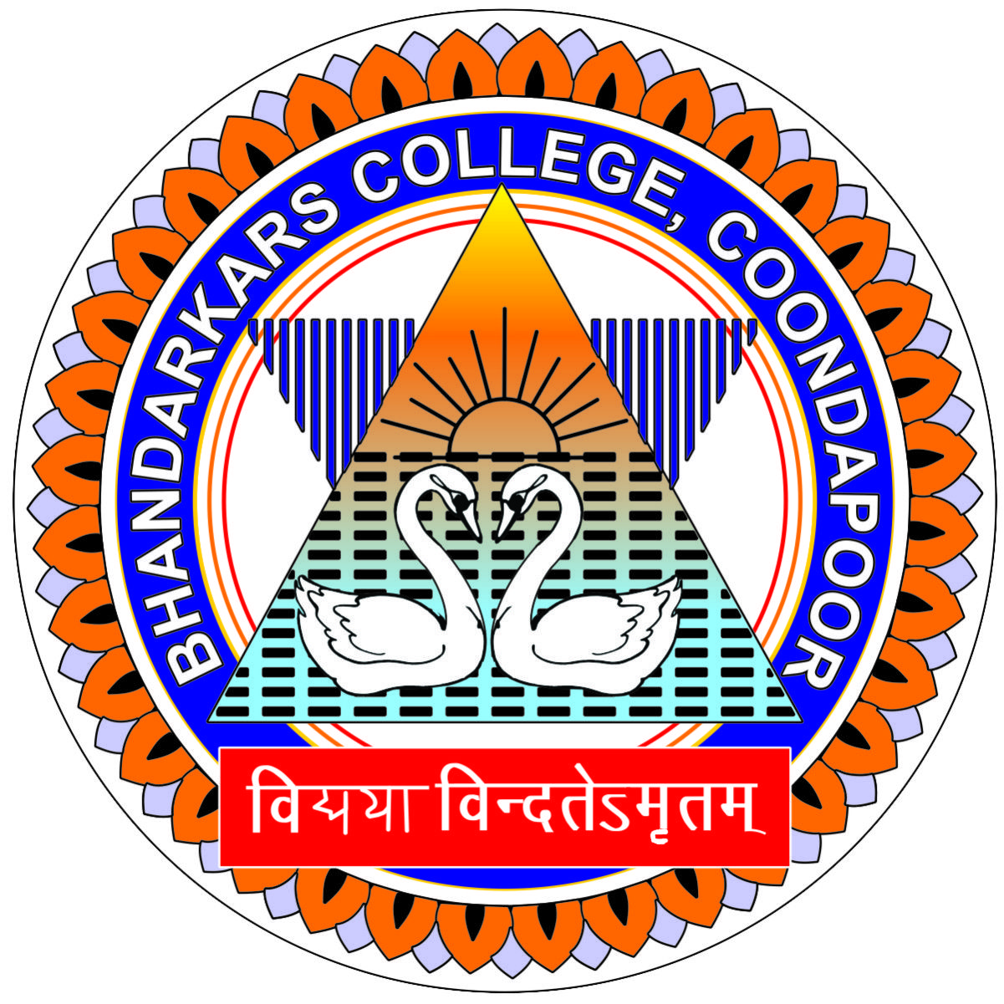

**2021-2022**

##### A PROJECT REPORT

###### ***Submitted by***

**SARVESH BHAT 191122795**

**SKANDA UDUPA 191122808**

**VIDHYABHUSHANA**

**MADHYASTHA 191122735**

In partial fulfillment for the award of the degree of

##### BACHELOR OF COMPUTER APPLICATIONS

***Under the guidance of***

**Mr. KRISHNA**

Lecturer

Department of Computer Science

**BHANDARKARS’ ARTS AND SCIENCE COLLEGE KUNDAPURA**

MANGALORE UNIVERSITY